**P**

**roducts ideal for your patients who**

**have Plantar Fasciitis, Achilles Tendonitis**

**and other lower extremity overuse injuries**

**.**

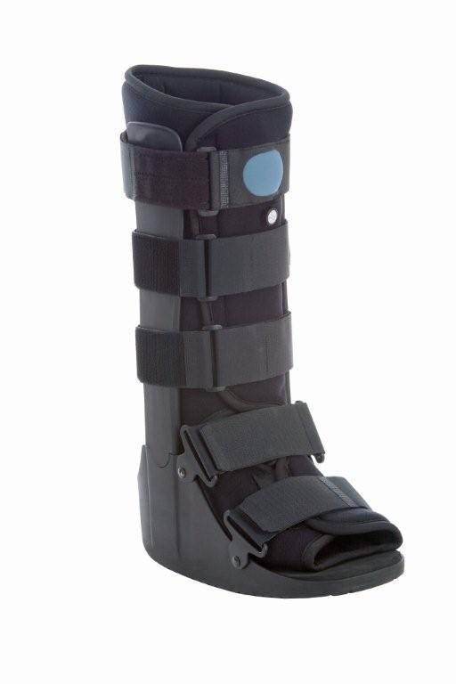

**Walker**

**Premium**

**Air**

**Ava**

**ilable in low top or standard height**

•

Low profile design provides comfort & stability

•

Air pump on front adjusts easily to achieve desired

compression

•

Adjustable medial/lateral air cell system inflates

both sides equally to accommodate changes in

edema during rehab

•

Fixed, aluminum malleable uprights allow for the

frame to contour better to the patient’s leg

•

Non-skid rocker sole is designed to help promote a

natural gait

•

**Indications**

Acute ankle sprains, soft tissue

:

injuries, stable fractures, post-operative use.

•

Available in 5 sizes

**L codes: L4360**

**Premium Walker**

**Available in low top or standard height**

•

Low profile design provides comfort and

stability

•

Fixed aluminum malleable uprights allow

for the frame to conform better to the

patient’s leg

•

Non-skid rocker sole is designed to help

promote natural gait

•

**Indications**

:

Acute ankle sprains, soft

tissue injuries, stable fractures, post-

operative use

•

Available in 5 sizes

**L Code: 4386**

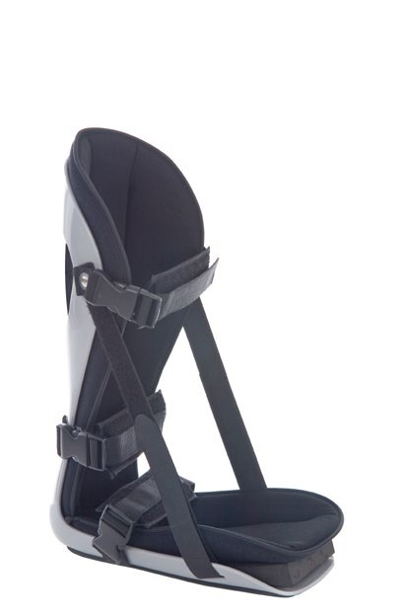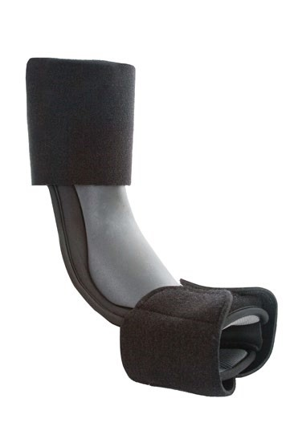

**Posterior Adjustable**

**Dorsal**

**Night Splint \***

**Night Splint**

**POSTERIOR ADJUSTABLE NIGHT SPLINT**

**:**

•

Adjustable flexion straps provide gentle stretching of the plantar fascia

and Achilles tendon

•

Adjust from 10 degrees to 90 degrees dorsi-flexion

•

Lightweight, sturdy, one piece flexible shell

•

Cool foam liner, padded calf and ankle straps for additional comfort

•

Shipped with toe wedge for additional stretch

•

**:**

**Indications**

Plantar Fasciitis, Achilles tendonitis

and other lower

extremity overuse injuries.

•

Available in 3 sizes (small, medium, large). *Extra Large available at $19.50 /each

**DORSAL NIGHT SPLINT**

:

•

Light- weight, low profile design for increased comfort and compliance

•

Slips on and adjusts easily

•

**Indications**

:

Plantar fasciitis, Achilles tendonitis, drop foot, and post

-

static pain.

•

Available in 2 sizes: small-medium and large-XLarge

**L Code: L4396**

**ComfortFit Orthotic Labs**

NIGHT SPLINTS & WAL

K

ERS 2025

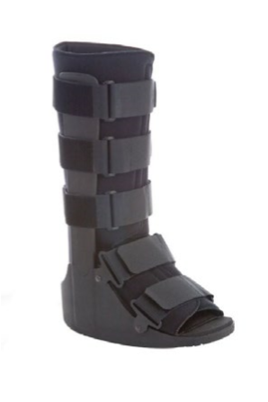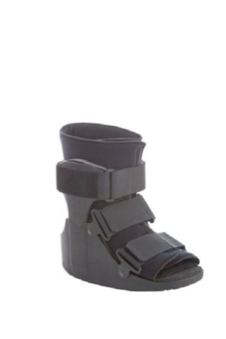

**ComfortFit Orthotic Labs**

**Columbus Avenue**

**246**

**Roselle, NJ 07203**

**1.888.523.1600**

**comfortfitlabs.com**

**contact@comfortfitlabs.com**